1. INTRODUCTION

1.1 Project Overview
Civil Engineering Insight Studio is an analytical and decision-support platform designed to assist civil engineers, urban planners, and infrastructure authorities in planning, designing, monitoring, and optimizing civil infrastructure projects. The studio integrates engineering data, analytical models, and visualization tools to provide actionable insights across domains such as transportation, structural health, water resources, and urban development.
Rapid urbanization, aging infrastructure, and increasing demand for sustainable development have made data-driven decision-making essential in civil engineering. Civil Engineering Insight Studio addresses these challenges by transforming raw engineering and environmental data into meaningful insights that support safer designs, efficient construction practices, and long-term infrastructure sustainability.
- Goals:
  - Provide an integrated platform for analyzing civil engineering data.
  - Support informed decision-making in infrastructure planning and design.
  - Improve safety, durability, and sustainability of civil structures.
  - Enable visualization and reporting for engineers and authorities.
- Features:
  - Structural Insight Module: Analyzes load distribution, stress factors, and safety margins for buildings and infrastructure.
  - Material Selection and Cost Analysis: Compare construction materials based on strength, durability, cost, and environmental impact.
  - Project Analytics Dashboard: Visualizes project timelines, estimated vs actual cost, and resource utilization.
  - Sustainability Assessment: Evaluates carbon footprint, energy efficiency, and green compliance metrics.
  - Risk & Safety Analysis: Identifies potential construction risks and suggests preventive measures.
2.IDEATION PHASE
2.1 Brainstorm & Idea Prioritization Template
Date | 28 January 2026
Team ID | LTVIP2026TMIDS84448
Project Name | Civil Engineering Insight Studio
Maximum Marks | 4 Marks

Brainstorming ideas is a creative process where a group generates a list of potential solutions, suggestions, or concepts for a specific problem or project voting in brainstorming involves participants selecting and prioritizing their favourite or most promising ideas from the list to determine which ones should be pursued further.

Brainstorming for Civil Engineering Insight Studio:
The ideation phase focused on identifying real-world problems in civil engineering such as inefficient planning, lack of predictive insights, maintenance delays, and limited data visualization. Brainstorming involved civil engineers, academicians, students, and infrastructure planners.
The brainstorming phase focused on identifying major challenges faced in modern civil engineering projects and proposing digital solutions to address them. The team explored ideas related to structural safety analysis, construction analytics, sustainability evaluation, and smart decision-support systems.
The core idea prioritized was the development of an insight-driven platform that transforms raw engineering and project data into actionable intelligence for civil engineers and planners.
Step-1 : Team Gathering, Collaboration and Select the Problem Statement
To initiate the Civil Engineering Insight Studio project, a multidisciplinary team was formed consisting of members with knowledge in civil engineering fundamentals, construction planning, data analysis, and software development. Each team member was assigned a specific role based on their strengths, ensuring effective collaboration and balanced contribution throughout the project lifecycle.
The team conducted multiple brainstorming and discussion sessions to understand the current challenges faced in civil engineering projects, particularly in the areas of structural safety, cost estimation, material selection, sustainability assessment, and project monitoring. Academic references, real-world construction case studies, and industry practices were reviewed to gain a deeper understanding of the gaps in existing systems.
During collaboration meetings, the team identified that many civil engineering projects rely heavily on manual calculations, static reports, and disconnected tools, which often result in design inefficiencies, delayed decision-making, safety risks, and cost overruns. The lack of a unified platform that provides integrated insights across different project parameters was recognized as a major problem.

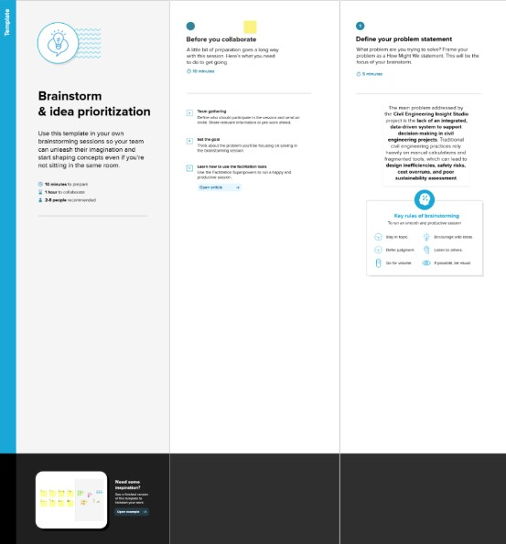

Step-2: Brainstorm, Idea Listing and grouping
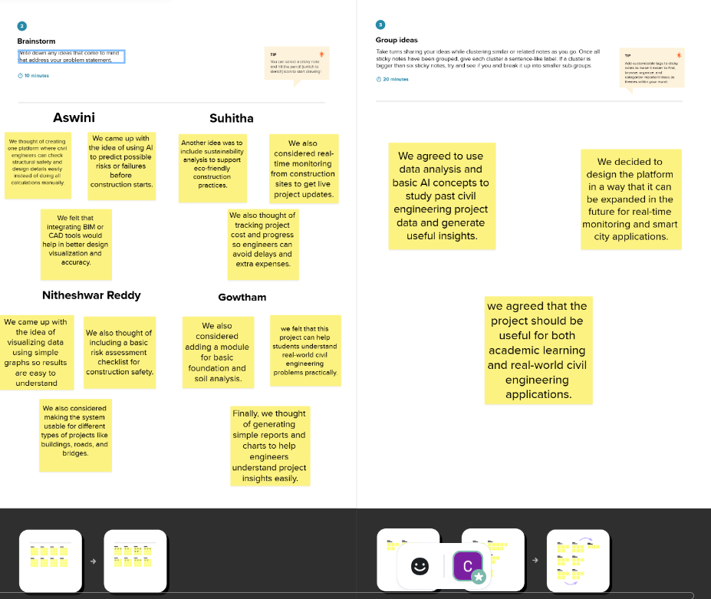

Step-3: Idea Prioritization
Idea prioritization is the process of ranking or assessing ideas based on specific criteria such as feasibility, impact, cost, or strategic importance to determine which ideas should be implemented or pursued first.
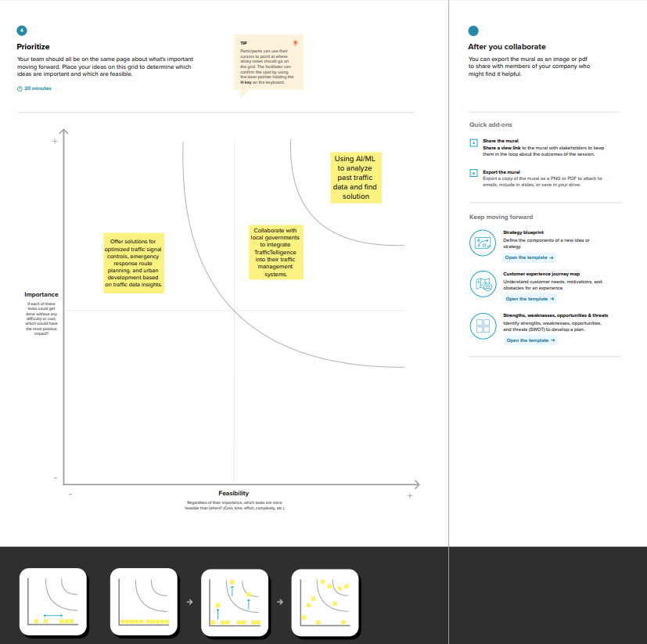
Here, we chose to use AI and data analytics to analyze past civil engineering data and provide better solutions for planning, design, and construction.
The second key idea involves collaborating with government and construction authorities to integrate Civil Engineering Insight Studio into public infrastructure planning, ensuring social impact and practical usability. The next idea focuses on extending the system to support optimized structural design and sustainable urban development through data-driven engineering insights.
2.2 Empathize & Discover
Date | 28 January 2026
Team ID | LTVIP2026TMIDS84448
Project Name | Project – Civil Engineering Insight Studio
Maximum Marks | 4 Marks

Empathy Map Canvas:
An empathy map is a simple, easy-to-digest visual that captures knowledge about a user’s behaviours and attitudes. It is a useful tool to helps teams better understand their users.
Creating an effective solution requires understanding the true problem and the person who
is experiencing it. The exercise of creating the map helps participants consider things from
the user’s perspective along with his or her goals and challenges.
Civil Engineering Insight Studio
Civil engineering challenges are among the major issues faced in modern infrastructure development. Rapid urbanization, increasing population, and growing construction demands have led to complex project planning, safety concerns, cost overruns, and sustainability challenges. Inefficient design decisions and lack of real-time analytical insights often result in structural risks, material wastage, and delayed project execution. Maintaining accurate visibility into structural performance, material usage, and project progress at every stage is essential for authorities and planners to make informed decisions related to infrastructure expansion, resource optimization, and sustainable urban development.
To address these challenges, data-driven analytics and AI-assisted engineering insights provide effective solutions by analyzing historical project data, structural parameters, material properties, and environmental factors. Such systems enable performance evaluation, risk identification, cost optimization, and sustainability assessment across various civil engineering projects. By leveraging analytical models and intelligent data processing, Civil Engineering Insight Studio supports engineers and decision-makers in designing safer, more efficient, and sustainable infrastructure systems.

3.REQUIREMENT ANALYSIS
3.1 Solution Requirements (Functional & Non-functional)
Date | 31 January 2026
Team ID | LTVIP2026TMIDS84448
Project Name | Civil Engineering Insight Studio
Maximum Marks | 4 Marks
3.1.1 Functional Requirements:
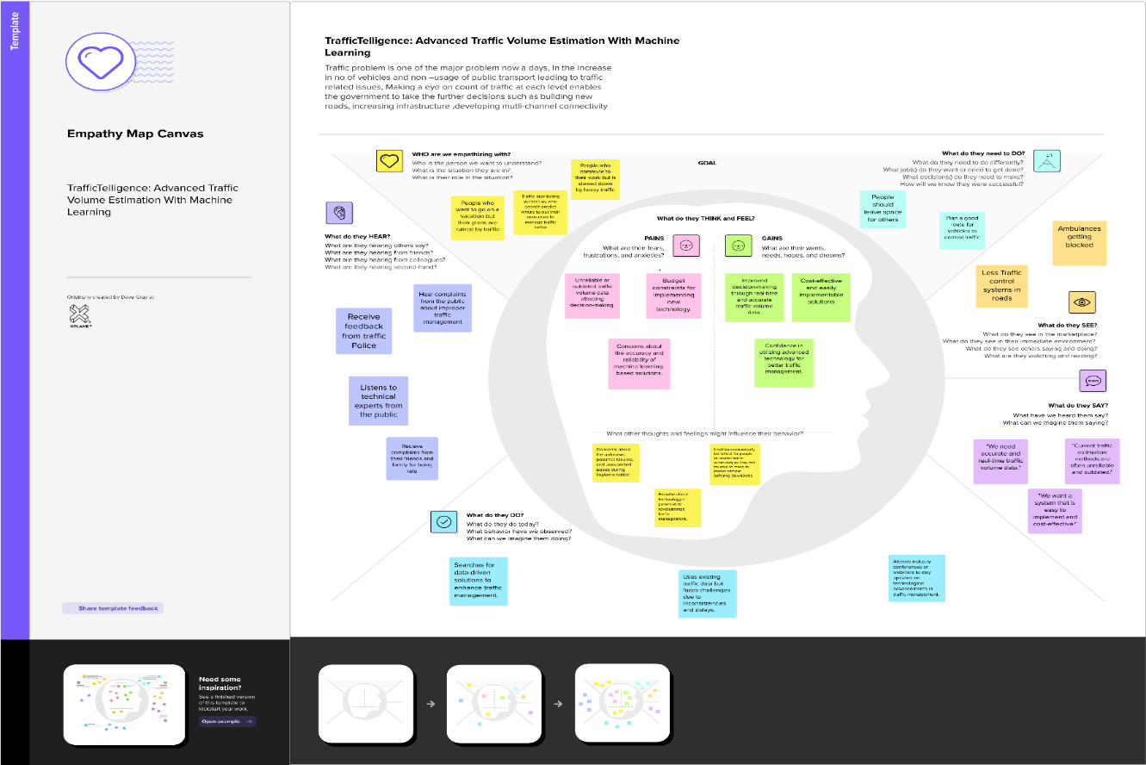
Following are the functional requirements of the proposed solution.

FR No. | Functional Requirement (Epic) | Sub Requirement (Story / Sub-Task)
FR-1 | Data Preprocessing & Validation | Convert raw project and design data into a clean and structured format Validate engineering inputs and remove inconsistencies
FR-2 | Structural Analysis & Classification | Analyze structural elements using engineering models  Classify components such as beams, columns, slabs, and foundations
FR-3 | Performance Analysis & Reporting | Evaluate structural performance and safety factors  Generate project-wise, daily, or phase-wise analytical reports
FR-4 | Insight Generation & Reporting | Estimate cost, safety, and sustainability metrics  Generate visual and tabular reports
3.1.2 Non-functional Requirements:
Following are the non-functional requirements of the proposed solution.
FR No. | Non-Functional Requirement | Description
NFR-1 | Usability | The system should provide an intuitive and user-friendly interface that allows civil engineers and planners to easily input data and interpret analytical results.
NFR-2 | Security | Data collected from surveillance should be securely stored and transmitted using encryption.
NFR-3 | Reliability | The system should maintain consistent accuracy in vehicle detection and count under various lighting and weather conditions.
NFR-4 | Performance | The ML model should process traffic data in near real-time with minimal latency.
NFR-5 | Availability | The system should be accessible 24/7 with minimum downtime, especially during peak traffic hours.

3.2 Data Flow Diagram & User Stories
Date | 31 January 2026
Team ID | LTVIP2026TMIDS84448
Project Name | Civil Engineering Insight Studio
Maximum Marks | 4 Marks
Data Flow Diagrams:
A Data Flow Diagram (DFD) is a traditional visual representation of the information flows within a system. A neat and clear DFD can depict the right amount of the system requirement graphically. It shows how data enters and leaves the system, what changes the information, and where data is stored.

Flow Diagram:

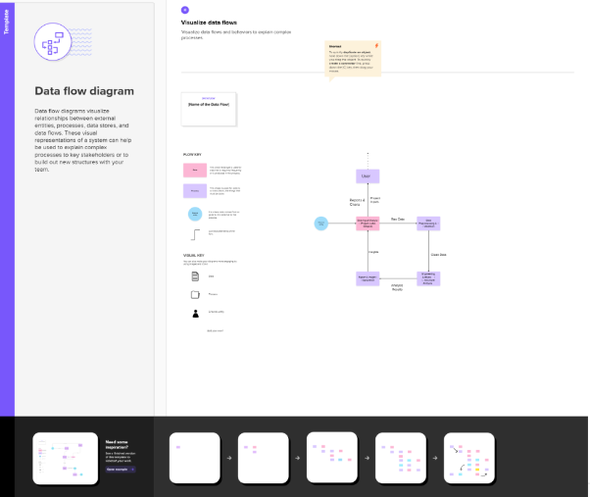
3.2.2 User Stories
Use the below template to list all the user stories for the product
User Type | Functional Requirement (Epic) | User  Story  Number | User Story / Task | Acceptance criteria | Priority | Release
Civil Engineer | Structural Performance AnalysisEstimation | USN-1 | As a Civil Engineer, I want to analyze structural loads and safety factors so that I can ensure safe and reliable designs. | System accurately calculates load distribution and safety factors. Results are clearly displayed and validated against standard engineering principles. | High | Sprint 1
SiteEngineer | Project Progress & Performance Monitoring | USN-2 | As a Site Engineer, I want to view project progress and performance insights to monitor construction activities effectively. | System displays updated project metrics such as progress status and performance indicators. | High | Sprint 1
Structural Analyst | Engineering Data Insights | USN-3 | As a Structural Analyst, I want detailed analytical reports showing stress, performance trends, and design comparisons. | Reports present clear insights across different project phases and design options. | Medium | Sprint 2
System Developer | Analytical Model Integration | USN-4 | As a System Developer, I want to integrate engineering analysis models into the platform for accurate and consistent insight generation. | Models provide reliable outputs and are well-documented for easy maintenance and expansion. | High | Sprint 2
Urban Planner | Customizable Infrastructure Insights | USN-5 | As an Urban Planner, I want customizable analytical insights to support different infrastructure development needs. | System allows parameter customization and adapts insights based on selected project conditions. | High | Sprint 3
Educational Institutions | Training Learning | USN-6 | As an academic user, I want the platform to support learning through engineering simulations and case-based analysis. | System supports testing with sample datasets and produces understandable analytical outputs. | medium | Sprint 4
QA Engineer | Testing & quality assurance | USN-7 | As a QA Engineer, I want to thoroughly test analytical modules and the interface to ensure accuracy and usability. | All modules function correctly with validated outputs and minimal errors after testing. | medium | Sprint 5

3.3 Technology Stack (Architecture & Stack)
Date | 31 January 2026
Team ID | LTVIP2026TMIDS84448
Project Name | Civil Engineering Insight Studio
Maximum Marks | 4 Marks
Technical Architecture:
The Deliverable shall include the architectural diagram as below and the information as follows:
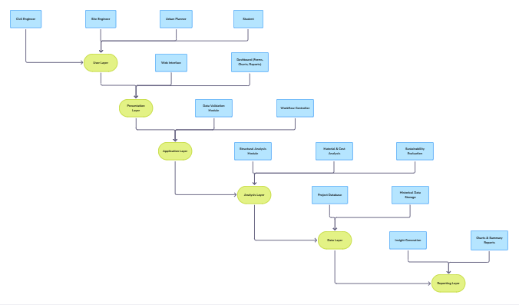
Table-1 : Components & Technologies:
S.No | Component | Description | Technology
1. | User Layer | End users such as civil engineers, site engineers, planners, and students interact with the system. | Web Browser
2. | Presentation Layer | Provides a user-friendly interface to enter project details and view analytical results. | HTML  CSS  JavaScript
3. | Application Layer | Validates user inputs and manages the flow of data between modules. | Python  Flask (Web Framework)
4. | Analysis Layer | Core component where structural safety, cost efficiency, and sustainability are evaluated. | Python  Engineering formulas & logic
5. | Data Layer | Stores project data, analysis results, and historical records for future reference. | CSV files  Local storage / File system
6. | Report Layer | Generates final insights, graphs, and reports for decision-making. | Python  Matplotlib / Charts  HTML reports

Table-2: Application Characteristics:
S.No | Characteristics | Description | Technology
1. | Open-Source Frameworks | Uses open-source tools to reduce cost and improve flexibility and maintainability. | Python’s Flask
2. | Scalability | The system can support multiple civil engineering project types such as buildings, roads, and bridges. | Modular architecture
3. | Performance | Provides fast analysis and report generation for engineering insights. | Efficient Python logic
4. | Availability | Accessible whenever required for project analysis and planning. | Local / Web deployment
5. | Usability | Easy-to-use interface suitable for engineers and students. | HTML, CSS
6. | Security | Protects project data from unauthorized access. | input validation, access control

4.PROJECT DESIGN

4.1 Problem – Solution Fit Template

Date | 2nd February 2026
Team ID | LTVIP2026TMIDS84448
Project Name | Civil Engineering Insight Studio
Maximum Marks | 2 Marks

Problem – Solution Fit Template:
The Problem-Solution Fit simply means that you have found a problem with your customer and that the solution you have realized for it actually solves the customer’s problem. It helps entrepreneurs, marketers and corporate innovators identify behavioral patterns and recognize what would work and why
Purpose:
- Solve complex problems in a way that fits the state of your customers.
- Succeed faster and increase your solution adoption by tapping into existing mediums and channels of behavior.
- Sharpen your communication and marketing strategy with the right triggers and messaging.
- Increase touch-points with your company by finding the right problem-behavior fit and building trust by solving frequent annoyances, or urgent or costly problems.
- Understand the existing situation in order to improve it for your target group.
Template:

References:
- https://www.ideahackers.network/problem-solution-fit-canvas/
- https://medium.com/@epicantus/problem-solution-fit-canvas-aa3dd59cb4fe

4.2 Proposed Solution Template
Date | 2nd February 2026
Team ID | LTVIP2026TMIDS84448
Project Name | Civil Engineering Insight Studio
Maximum Marks | 2 Marks

Proposed Solution Template:
Project team shall fill the following information in proposed solution template.

S.No. | Parameter | Description
1. | Problem Statement (Problem to be  solved) | Civil engineering projects face major challenges due to rapid urbanization, complex design requirements, and increasing infrastructure demands. Traditional engineering practices rely heavily on manual calculations, disconnected tools, and static reports, which can lead to design inefficiencies, safety risks, cost overruns, and poor sustainability assessment. Limited availability of integrated analytical platforms makes it difficult for engineers and planners to evaluate structural performance, optimize material usage, and monitor project progress effectively. Hence, there is a need to develop an integrated, data-driven system that can analyze civil engineering project data, provide accurate insights on structural safety, cost efficiency, and sustainability, and support informed decision-making throughout the project lifecycle.
2. | Idea / Solution description | Civil Engineering Insight Studio is an analytical platform that processes structural, material, cost, and environmental data to generate meaningful engineering insights. The system helps engineers evaluate structural safety, compare materials, monitor project performance, and support informed decision-making through dashboards and reports.
3. | Novelty / Uniqueness | The uniqueness of this project lies in combining multiple civil engineering analysis aspects—structural safety, material optimization, cost analysis, and sustainability—into a single unified insight platform. This integrated approach reduces dependency on multiple tools and manual calculations.
4. | Social Impact / Customer Satisfaction | The project contributes to safer and more sustainable infrastructure by reducing design errors and material wastage. It supports engineers, planners, and students in making reliable decisions, ultimately benefiting society through improved construction quality and safety.
5. | Business Model (Revenue Model) | The platform can be offered as a licensed software solution for construction firms, engineering consultancies, and government departments. It can also be used as an educational tool for institutions, with potential subscription-based access for advanced features.
6. | Scalability of the Solution | Civil Engineering Insight Studio is scalable and can be extended to support different project types such as buildings, roads, bridges, and smart city infrastructure. Future enhancements like AI-based prediction, real-time monitoring, and cloud deployment can further improve scalability and usability.

4.3 Solution Architecture
Date | ^{5th} February 2026
Team ID | LTVIP2026TMIDS84448
Project Name | Civil Engineering Insight Studio
Maximum Marks | 4 Marks

Solution Architecture:
The Civil Engineering Insight Studio follows a modular and layered architecture that enables efficient data processing, analysis, and insight generation. The system is designed to accept civil engineering project data, validate it, perform analytical computations, and present meaningful insights through an interactive interface.
Steps to be followed: -
- User Login & Project Creation
The user logs into the system and creates a new civil engineering project.
- Project Data Input
Users enter project details such as structure type, loads, materials, dimensions, and site conditions.
- Data Validation
The system checks the entered data for errors, missing values, and invalid inputs.
- Data Preprocessing
Valid data is formatted and prepared for analysis.
- Engineering Analysis
Structural safety, material optimization, cost estimation, and sustainability analysis are performed.
- Result Storage
Analysis results and project data are stored in the database for future reference.
- Insight Generation
The system generates insights, charts, and performance indicators.
- Report Visualization
Results are displayed through dashboards and downloadable reports.
- Decision Support
Engineers and planners use the insights to make informed design and planning decisions.
- Feedback & Iteration
Users can modify inputs and re-run the analysis for improved outcomes.

- PROJECT PLANNING & SCHEDULING

5.1 Project Planning Template (Product Backlog, Sprint Planning, Stories, Story points)

Date | ^{5th} February 2026
Team ID | LTVIP2026TMIDS84448
Project Name | Civil Engineering Insight Studio
Maximum Marks | 5 Marks

Product Backlog, Sprint Schedule, and Estimation (4 Marks)
Use the below template to create product backlog and sprint schedule
Sprint | Functional Requirement (Epic) | User Story Number | User Story / Task | Story Points | Priority | Team Members
Sprint-1 | Project Setup & Infrastructure | USN-1 | Configure the project environment by installing required software tools, libraries, and frameworks needed for developing the Civil Engineering Insight Studio. | 1 | Medium | Suhitha, Aswini
Sprint-1 | Data Collection& Preprocessing | USN-2 | As a developer, I want to collect and preprocess civil engineering project data (loads, materials, dimensions) so that it can be used for analysis and insight generation. | 2 | High | Gowtham, Niteesh
Sprint-2 | Analysis Module Integration | USN-3 | As a developer, I want to integrate structural safety, material optimization, and cost analysis modules into the web application to provide engineering insights. | 2 | High | Aswini, Suhitha
Sprint-3 | Error Handling & Input Validation | USN-4 | As a user, I want to receive proper error messages when incorrect or incomplete project data is entered so that I can correct it easily | 2 | High | Suhitha, Aswini, Niteeshwar Reddy, Gowtham

- FUNCTIONAL AND PERFORMANCE TESTING
6.1 Model Performance Test
Date | 12th February
Team ID | LTVIP2026TMIDS84448
Project Name | Civil Engineering Insight Studio
Maximum Marks | 10 Marks

Model Performance Testing:
Project team shall fill the following information in model performance testing template.
S.No | Performance Test Type | Description | Expected Result
 | Response Time Testing | Measures the time taken to process inputs and display analysis results. | Results are generated within acceptable time limits without delay.
 | Load Testing | Evaluates system behaviour when multiple users access the application simultaneously. | System remains stable and responsive under normal load.
 | Scalability Testing | Check’s ability to handle increased users and project data. | Performance remains consistent as usage increases.
 | Resource Utilization Testing | Monitors CPU, memory, and storage usage during analysis. | Optimal resource usage without excessive consumption.
 | Throughput Testing | Measures number of analysis requests processed per unit time. | System processes multiple requests efficiently.

7. RESULTS
7.1 Output Screenshots
The complete execution of the Civil Engineering Insight Studio application is shown below through a series of step-by-step screenshots:

Step 1: Running the Streamlit Application
- Run the app.py file from your terminal or VS Code.
- You will see the Streamlit server starting message.
- The application will be accessible at:
http://10.84.207.131:8501
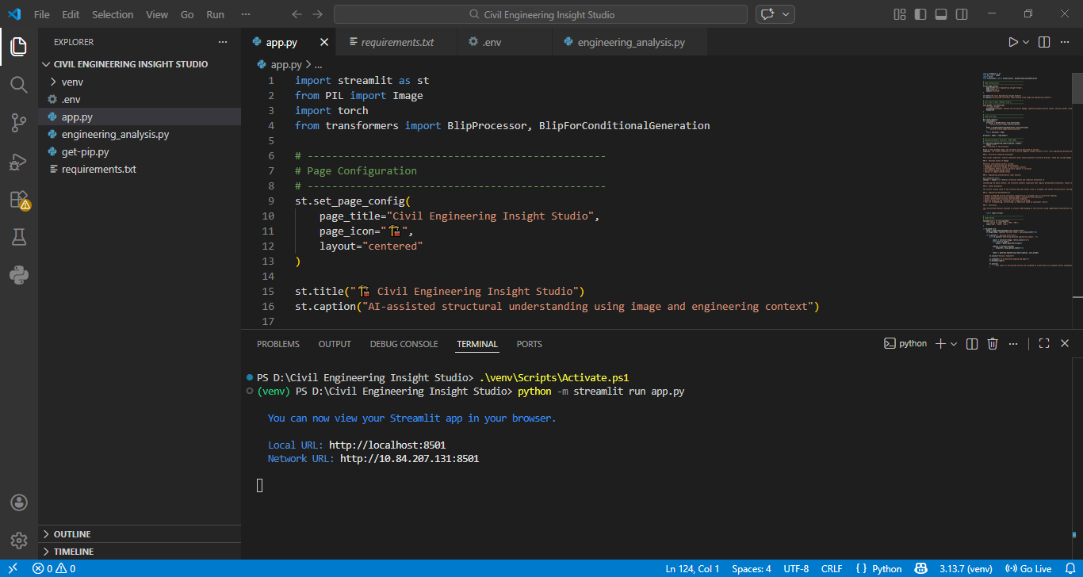
Fig 7.1.1:code running in terminal
Step 2: Opening the Application in Browser
Open your browser and navigate to:
- http://localhost:8501
The Home Page will appear with a clean and simple interface to input:
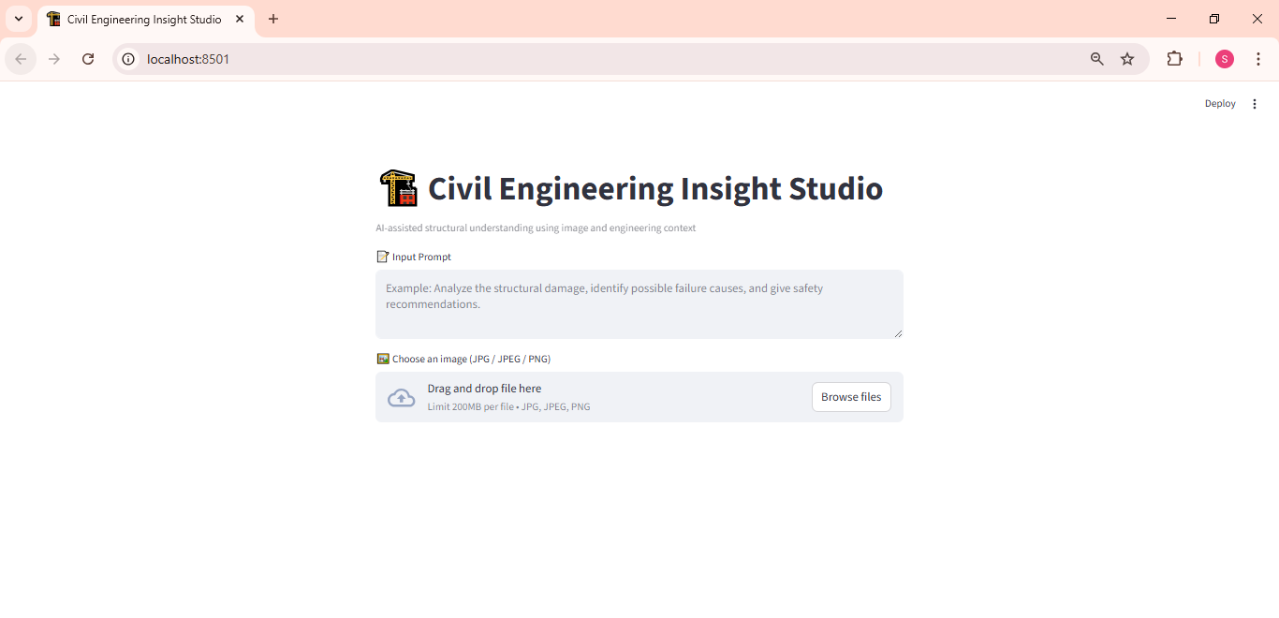
Fig 7.1.2:Home page Interface

Step 3: Submitting the Form for Prediction
- Drag the image click enter.
- The backend processes the request using the trained model and encoder.

Fig 7.13: Input the image

Step 4: Viewing the Prediction Output
- The predicted insights /reports shown below:
- Screenshot Example:
- 📸 Prediction result shown below the form: " Civil Engineering Insight Studio: Reports "
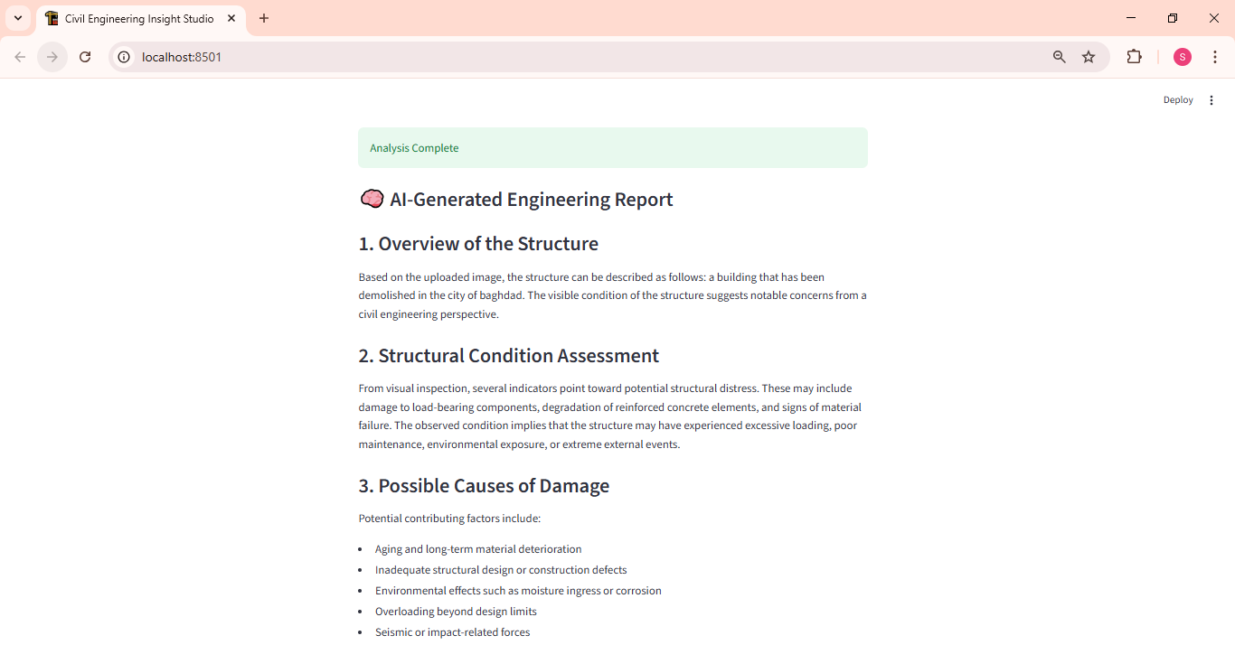

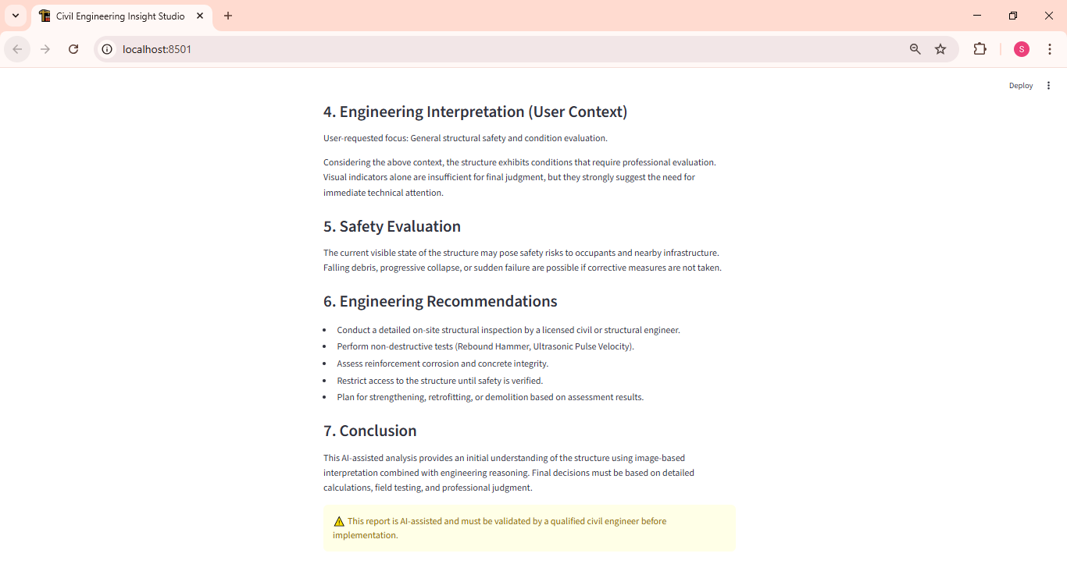
Fig 7.1.4: Predicted Outputs

8. ADVANTAGES & DISADVANTAGES
8.1 Advantages:
1. Improved Decision-Making
Provides data-driven insights that help civil engineers and planners make informed decisions during design and construction phases.
2. Enhanced Structural Safety
Analyzes loads, stress, and safety factors, reducing the risk of structural failures and improving reliability.
3. Cost Optimization
Supports material comparison and cost analysis, helping minimize construction expenses and material wastage.
4. Time Efficiency
Reduces manual calculations and report preparation by automating analysis and insight generation.
5. Sustainability Support
Evaluates environmental impact and promotes eco-friendly construction practices.
6. Better Project Monitoring
Helps track project performance, progress, and key metrics throughout the project lifecycle.
7. Scalability
Can be extended to different civil engineering domains such as buildings, roads, bridges, and urban infrastructure.
8. Academic & Industry Use
Useful for students, researchers, and professionals for learning, analysis, and planning purposes.
8.2 Disadvantages
1. Dependency on Input Data Quality
Incorrect or incomplete project data can lead to inaccurate analysis and insights.
2. Initial Setup Effort
Requires time and effort to configure analytical models and project parameters.
3. Limited Real-Time Integration
Early versions may not support live site data or sensor integration.
4. Learning Curve
Users may need basic training to effectively use analytical features and dashboards.
5. Computational Requirements
Complex analysis may require higher computational resources for large projects.
6. Limited Automation in Early Stages
Some engineering decisions may still require manual validation and expert judgment.

9. CONCLUSION
The Civil Engineering Insight Studio project can be enhanced by integrating advanced AI and machine learning models for predictive analysis and failure detection. Real-time data from construction sites and sensors can be incorporated for live monitoring. Integration with BIM and CAD tools will improve design accuracy and collaboration. Cloud-based deployment can enable multi-user access and large-scale project handling. The platform can also be expanded to support smart city and infrastructure planning applications.

10. FUTURE SCOPE
The Civil Engineering Insight Studio project can be enhanced using AI/ML for prediction and real-time monitoring. Future scope includes BIM/CAD integration, cloud deployment, and smart infrastructure planning. However, there are several opportunities to enhance its functionality, scalability, and usability in the future:
- Advanced AI and Machine Learning Integration
The system can be enhanced by incorporating advanced AI and machine learning models to predict structural failures, cost overruns, and project delays. This will improve decision-making accuracy and risk management.
- Real-Time Site Data Integration:
Future versions can integrate real-time data from construction sites using sensors, IoT devices, and monitoring tools to provide live updates on project progress, safety conditions, and material usage.
- BIM and CAD Tool Integration:
Integration with Building Information Modeling (BIM) and CAD software will allow engineers to visualize designs, detect clashes, and perform more accurate simulations within the platform.
- Cloud-Based Deployment:
Deploying the system on the cloud will enable multiple stakeholders to access the platform simultaneously, improve data storage, and support large-scale infrastructure projects.
- Smart City and Infrastructure Planning:
The platform can be extended to support smart city initiatives by analyzing data related to roads, bridges, drainage systems, and urban development, aiding long-term infrastructure planning and sustainability.
- Mobile Application Support:
Developing a mobile application will allow engineers and planners to access insights, reports, and alerts anytime, improving field-level decision-making and coordination.

11. APPENDIX
Source Code:
All codes are submitted in Git-Hub Repository.
Git-Hub Repository Link:
https://github.com/Prajna543/Civil_Engineering_Insight_Studio
Project Demo Link:

https://drive.google.com/file/d/1hH2cY8PYP7uOMFGMO9Jp_yFSbTF3ZNq4/view?usp=sharing

